Screen 0: Full Download Screen  Objects:  Progress bar, message (percent completed if available), exit button  Functions:  On application load, program will connect to the server and download full list of user credentials, vehicles, routes and etc.  If there are any not synced data on the device it will be send to the server.  Exit button will close application.  Error message will be displayed if application not able to communicate with the server.  Comments:  Questions: | 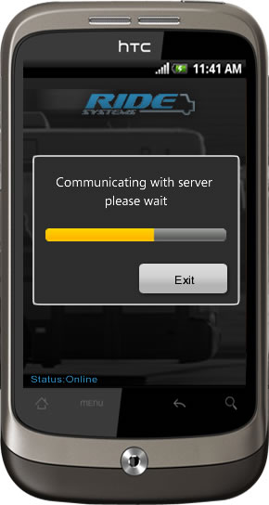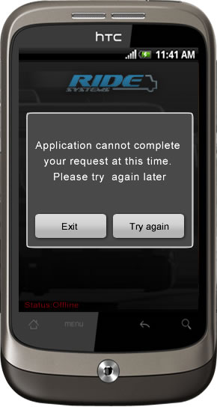
Screen 1: Login Screen  Objects:  Username text box, Password text box, Exit Button, Login Button, Online status indicator  Functions:  Exit button will close this application.  Login button will authenticate user credentials against locally stored user database.  If user fails to provide valid credentials “Can’t sign in” Error message will pop up. | 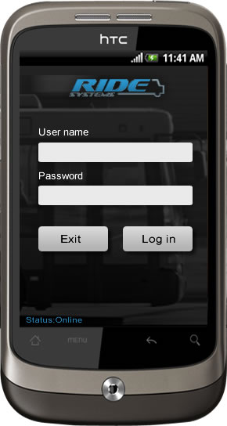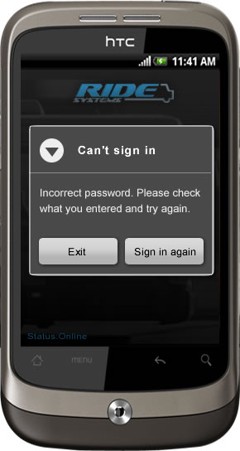
Screen 1(Option2, 3): Login Screen  Functions:  Depending on “Login Requirements” config option user will see one of the screens.  1 Username and Password Text boxes  2 Username drop down and password text box  3 Username drop down, no password box | 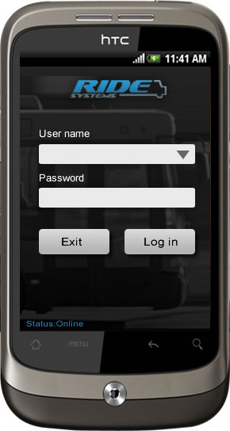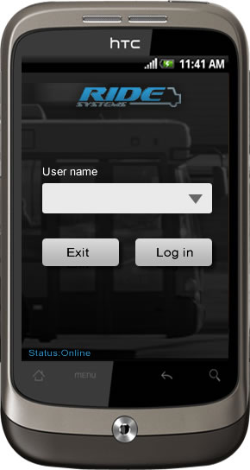
Screen 1: Login Screen (Error Msg)  Functions:  In an event application does not have initial database downloaded. (Application status is offline)  Or application is in the process of downloading.  And User is trying to sign in. Detailed Error message will be displayed.  Comments:  Questions: | 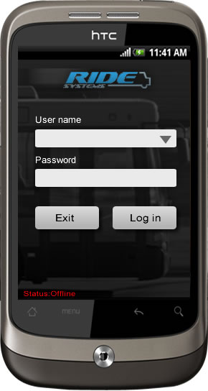
Screen 2: Select Route Screen  Objects:  Logo and Screen name will appear at the top of the screen. Driver Name, Route and Vehicle drop down boxes.  Functions:  User will have an option to select route and vehicle from drop down. (Information will be pulled from local storage)  Menu options on this screen:  - Application status  - Sync  - Logout  Comments:  Questions: | 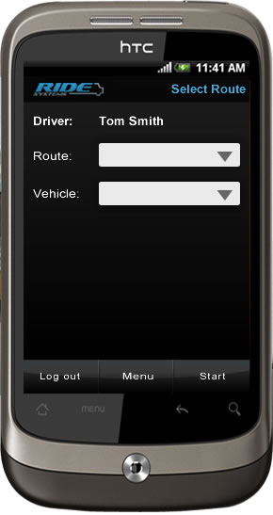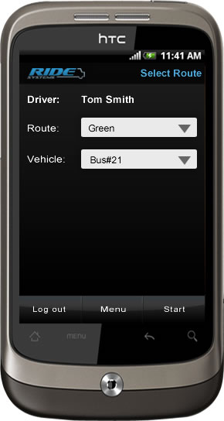
Screen 2: Select Route Screen  Objects:  Functions:  If user will press start button without selecting vehicle or route, detail error message will appear  Comments:  Questions: | 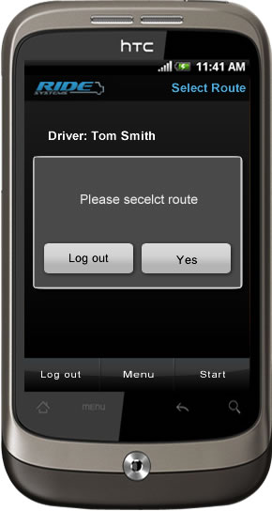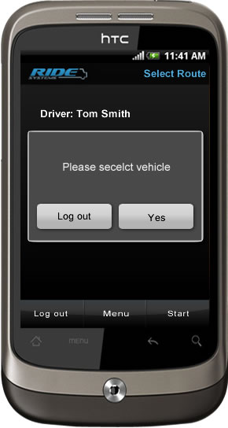
Screen 3: Passenger Count Screen  Objects:  Logo and screen name at the top of the screen.  Count main category, and up to 3 subcategories with “-” and “+” buttons next to them. Additional top-level count category button. Stop name, Bus name and route name.  Functions:  User will be able to add/remove count for selected category, subcategory using “+” and “-“ button.  See description on category structure below.  Comments:  Questions: What route and stop numbers will represent? Total count of the passengers 1 category - 1 subcategory? | 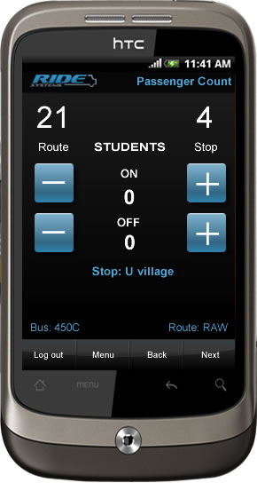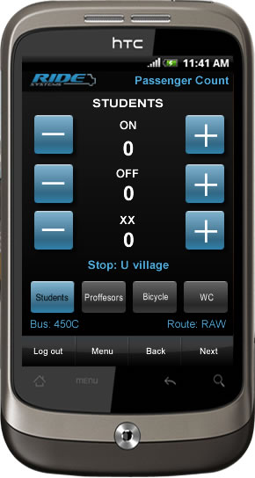
Screen 4: Passenger Count Screen  Objects:  Logo, Screen name, Stop, Bus, Route, Count category, numerical keypad  Functions:  This screen will appear if driver will need to count one category and one subcategory.  Comments:  Questions: What route and stop numbers will represent? Total count of the passengers 1 category - 1 subcategory?  Do we need to display category subcategory name? | 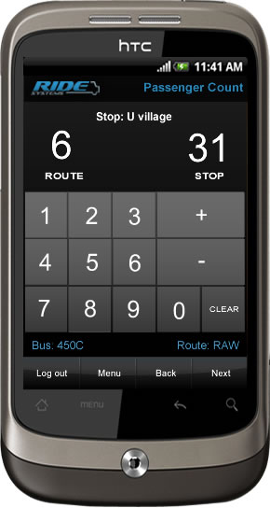
Screen 1: Summary – End of Route Screen  Objects:  Logo, Screen name, List of categories and count. Bus name and route name.  Functions:  This screen appears at the end of the route and contains totals of all counts across all available categories.  On logout action user will prompt to confirm his/here action  Comments:  Questions: | 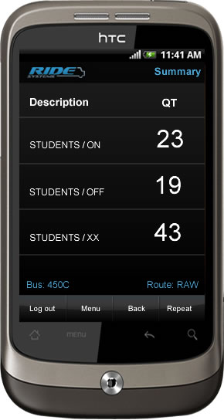
Screen 2: Menu Screen  Objects: List of menu options  Functions:  - On the route menu options:  - Go to Start  - Go to End  - Go to Stop  - End the route  - Show Map  - Application Status  - Sync  - Logout  End of the route will take the user to the route and vehicle selection screen.  Buttons at the bottom of the screen will be preserved from initial screen where user selected menu.  Comments:  Questions: | 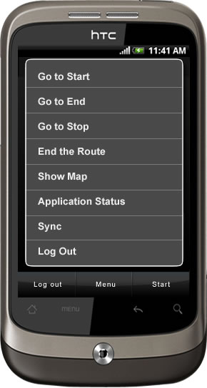
Screen 3: Stop Selection – Go To Stop Screen  Objects: Logo, Screen Name, List of Stops for the route, Bus name, Route Name.  Functions:  This screen contains list of the routes. User will have ability to jump to the selected stop.  Buttons at the bottom of the screen will be preserved from initial screen where user selected menu.  Comments:  Questions: | 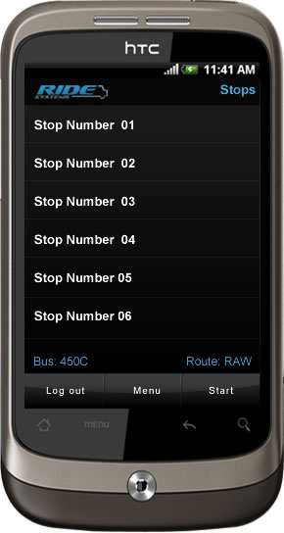
Screen 4: Status Screen  Objects: List of application statuses  Functions:  Buttons at the bottom of the screen will be preserved from initial screen where user selected menu.  Comments:  Questions: | 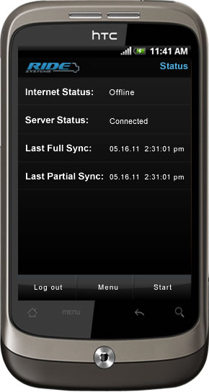

Categorization
Application will track up to n number of fist level categories and up to three subcategoty.(As illustrated on Screen 3)
Example 1: one category “Students” and two subcategories “On” and “Off”
Example 2: 4 categorues “Students”, “Professors”, “Bycycles”, “WC – Wheelchaire” and three subcategorie “On”, “Off” and “XX”. In this example user will have ability to swich between categories by pressing new category button: from “Students” to “Professors.”
Example 2: one category “Student” and one subcategory “On”.

Metadata Management
Full list of categories and subcategories will downloaded from Web service on every user login event, as a result in order to update any metadata user can logout and log back in.
Use Case: metadata on the server has been changed during the route. Application will submit passenger count for stops and categories that have been modified on the server. Server should accept all count for updated stops.

Authentication
Every web service request will contain client token. This token will identify individual organization using this application. No web service authentication presently used. This might cause a security thread in the future.

Offline storage and Syncronization
Application will try to syncronize in a background thread where posseble. This will allow application to perfome fast and inedependent of sync. During full synchronization application for example befor fist login application will synchronize using main UI thread.
All user actions should be stored in local storage and syncronized with the server in a background thread at the end of the route.

Web Service
http://www.ridesystems.net/RideServices1_2/RideWCFService.svc

Configurations
Following parameters should be configurable on a device:

Web Service URL
Client Token
Login Requirements
Client website

Ability to configure audio effects for the following user actions:
Plus button pressed
Minus button pressed
Clear button pressed
Numeric button pressed

Distribution
This application will be distributed as an “apk” file. Ride Systems will be provided with APK file 2 time per week during development for internal testing putpuses.
(Due to specific audience fo this application it won’t be distributed over the Marketplace)

Supported operating systems:
Application should perform as expected on: Android 2.1 and above.

Screen Resolution:
Screen resolution will vary per device. Application will be designed to support screen resolutions
480x800px. Application will function in different screen resolution, however, may look different.

Aditinal functionality
Menu button and Back button will be disabled by application. We’ll try to disable Search and Home button where posseble.
If home button pressed user will be able to return to the application in the same state.

Design
Design presented in this SOW made with an asumption that native android coltrols will be used. As a result final product may look different.

